Recommendations on Bitdefender Total Security

Harpreet Singh

Computer Engineering Technology - Computing Science

Algonquin College

March 25th, 2025

ENL2019T 309

Summary

The problem this report examines is the need for stronger cybersecurity measures.

This study explores cybersecurity solutions to protect digital systems and data.

The criteria the solution is tested against are effectiveness, cost, and ease of implementation.

The recommendation is to adopt Bitdefender Total Security as the cybersecurity solution.

Table of Contents

Summary ii

List of Figures iv

List of Tables v

1.0 Introduction 1

2.0 Problem Statement 2

2.1 Background - Problem: Increasing Cyber Threats 2

2.2 Theory - Solution: Implementing Bitdefender Total Security 2

3.0 Criteria 3

3.1 Maintenance 3

3.2 Cost 3

3.3 Performance 3

4.0 Results and Discussion (Criteria vs. Solution) 4

4.1 Security Enhancements with Bitdefender Total Security 4

4.2 System Compatibility 4

4.3 Cost 4

5.0 Conclusion 5

6.0 Recommendation 6

References 7

# List of Figures

Figure 1: CyberSecurity Threats [1] 2

Figure 2: *: Data Security Enhancement* [2] 4

Figure 3: *System Compatibility and speed* [3] 5

Figure 4: *: Cost Friendly Software* [4] 5

# List of Tables

Table 1:Bitdefender Total Security Recommendation Criteria 6

# 1.0 Introduction

The purpose of this report is to make a recommendation on cybersecurity solutions.  
The intended audience for this report will include technicians and professionals in the field of information security and technology. This report examines the issue of increasing cyber threats and the need for robust security measures. The proposed solution is the implementation of cybersecurity strategies, including encryption, firewalls, and threat detection systems, to protect sensitive data and systems.  
Chapter 2.0 of this report discusses the problem in detail and presents the proposed solution. Chapter 3.0 outlines the evaluation criteria used to assess Bitdefender cybersecurity measures. Chapter 4.0 presents a comparative analysis of Bitdefender Total Security against the criteria.  
Chapter 5.0 summarizes the findings and presents the overall conclusion of the study.  
Chapter 6.0 offers a recommendation based on the analysis conducted in the previous sections.

# 2.0 Problem Statement

## 2.1 Background - Problem: Increasing Cyber Threats

As a daily computer user, I have noticed unusual network activity where certain applications attempt to access the internet without my explicit permission. Despite having a firewall and antivirus software, unauthorized connections to external servers raise concerns about potential cybersecurity threats, such as spyware, keyloggers, or hidden malware. This activity could compromise sensitive information, including login credentials, personal files, and financial data. The challenge is to identify the source of these unauthorized connections, prevent potential data leaks, and implement a cybersecurity solution that enhances visibility and control over internet access for installed applications.

## 2.2 Theory - Solution: Implementing Bitdefender Total Security Threats

Bitdefender Total Security provides a strong defense against cyber threats by offering real-time protection, advanced threat detection, and AI-driven security measures. The solution includes a firewall, ransomware protection, anti-phishing tools, and a secure VPN. The solution must be cost-effective and responsive to emerging security challenges while ensuring digital asset protection.

(See Figure 1 for a visual representation of cybersecurity threats.)

## A computer screen with symbols and words

*Figure 1: Cybersecurity Threats [1]*

# 3.0 Criteria

## 3.1 Maintenance

The cybersecurity solution should require minimal maintenance while ensuring continuous protection. Bitdefender provides automated updates and security patches, reducing manual intervention.

## 3.2 Cost

The solution should be cost-effective, with a budget goal of under $500.00. Bitdefender Total Security offers multi-device protection with an affordable annual subscription.

## 3.3 Performance

Bitdefender should provide robust protection against malware, ransomware, and phishing attacks. It must support real-time monitoring, AI-driven threat detection, and high encryption standards. High encryption standards should be supported by systems to protect sensitive information and guarantee a safe and dependable environment.

# 4.0 Results and Discussion (Criteria vs. Solution)

## 4.1 Security Enhancements with Bitdefender Total Security

Bitdefender meets the criterion for effective cybersecurity by offering advanced threat detection and network monitoring. It ensures real-time protection, anti-phishing capabilities, and secure VPN configurations.[2]

This meets the criterion for faster data transfer speeds.

The multi-layered cybersecurity framework includes advanced encryption and optimized data routing to maintain high-speed data transfer (see Figure 2).



*Figure 2: Data Security Enhancement [2]*

## 4.2 System Compatibility

The goal is to enhance overall system performance by minimizing latency and improving access times for applications and operating systems.

Data on cybersecurity efficiency is obtained from Bitdefender. It reports that security solutions use advanced threat intelligence and behavioral analysis to detect and neutralize threats with minimal system overhead, ensuring smooth and uninterrupted performance [3].

This meets the criterion for compatibility with software and hardware.

This cybersecurity framework ensures real-time threat detection with minimal impact on system speed (see Figure 3).



*Figure 3: System Compatibility and speed [3]*

## 4.3 cost

The goal is to launch the software maintenance for under $500.00.

Data on cybersecurity pricing is obtained from Bitdefender. Bitdefender reports that its security solutions offer competitive pricing, with Bitdefender Total Security available for approximately $39.99 for the first year (covering 5 devices), and Bitdefender Internet Security priced around $34.99 for 3 devices. The Antivirus Plus package is available for $29.99 for 3 devices, making it an affordable yet robust cybersecurity solution [4].

This meets the criterion for cost-effectiveness. (See figure 4)

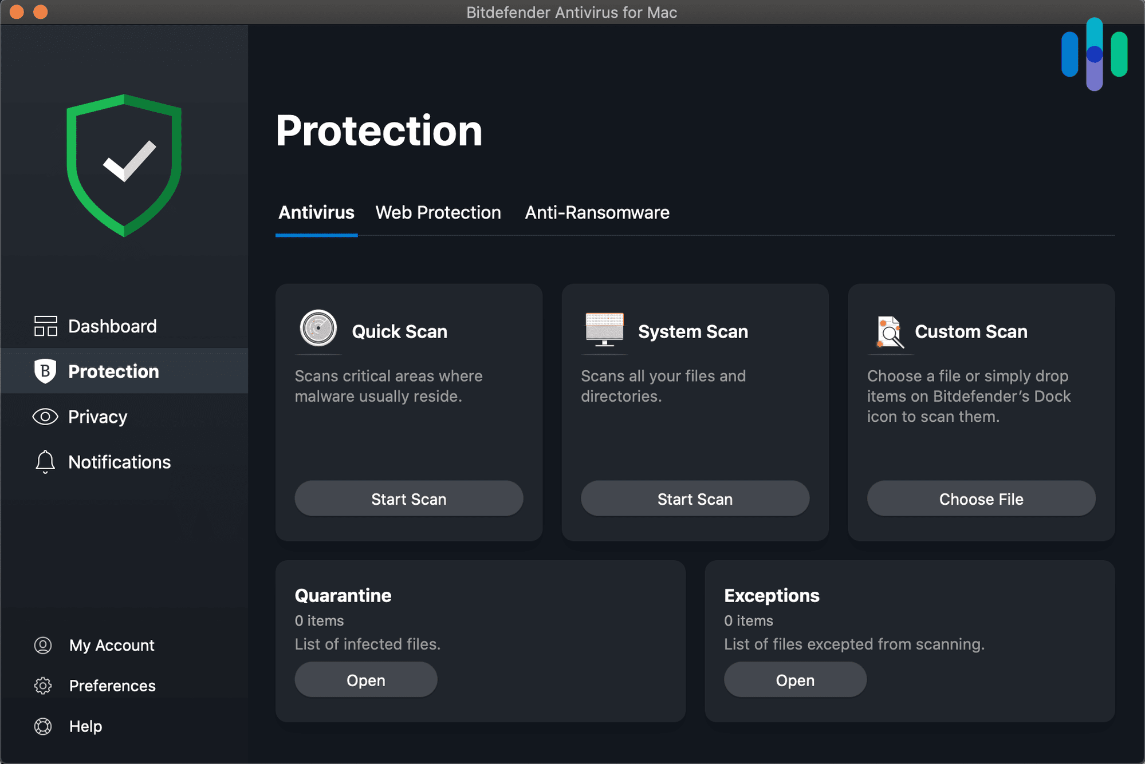

*Figure 4: Cost Friendly Software [4]*

# 5.0 Conclusion

Bitdefender Total Security is a comprehensive cybersecurity solution that provides real-time protection against malware, ransomware, phishing, and advanced cyber threats. Its AI-driven detection system ensures proactive defense, while its multi-layered security approach safeguards sensitive data. Additionally, it offers features such as a secure VPN, password manager, and parental controls, making it an ideal choice for individuals and businesses. With its cost-effectiveness, low system impact, and strong user reviews, Bitdefender Total Security stands out as a reliable and efficient solution for modern cybersecurity needs​.

All criteria for the Bitdefender Total Security were passed (See Table 1).

Table 1: Bitdefender Total Security Recommendation Criteria

|  |  |  |
| --- | --- | --- |
| **Criteria** | **Pass** | **Fail** |
| Maintenance | x |  |
| cost | x |  |
| Performance | x |  |

# 6.0 Recommendation

Given its security enhancements, cost-effectiveness, and compatibility, it is recommended to implement Bitdefender Total Security as the primary cybersecurity solution.

# References

|  |  |
| --- | --- |
|  | [1] CyberSecurity Threats modern era[Online]. Available: [https://cybersecuritythreats.com.](https://www.bitdefender.com/solutions/total-security.html.) [Accessed 24 2 2025]. |
|  | [2] Bitdefender total Secuirty under cost effectiveness system compatibility and fast and which is freee[Online]. Available: <https://www.bitdefender.com/solutions/total-security.html.>[Accessed 3 2 2025 |
|  | [3] Samsung ios security problems[Online]. [Available https://semiconductor.samsung.com/consumer-storage/internal-ssd/980pro/.](Available%20https:/semiconductor.samsung.com/consumer-storage/internal-ssd/980pro/.%20) [Accessed 3 2 2025]. |
|  | [4] Different solutions for cyberseurity bitdefender[Online]Available.<https://www.bitdefender.com/solutions/total-security.html.> [Accessed 3 2 2025]. |